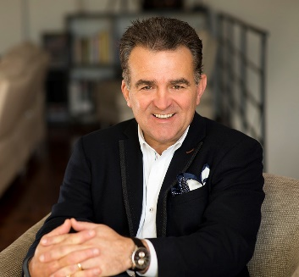
Jon Michail | Image Consultant | Personal Branding Coach | Business and Personal Branding Strategist | Author | Group CEO and Founder, Image Group International |
Image Group International are Entrepreneurial Activists… Rebels With a Cause!

Jon Michail, Founder and award-winning Chief Imagemaker together with his team at Image Group International help executives, entrepreneurs and changemakers to build, grow and monetise their personal brands, (online and offline) by positioning them to stand out so they attract their ideal clients connections and investors.
They are committed to maximising an individual’s personal impact, influence and value in the ever-changing and disruptive business environment.
Image Group International is recognised as Australia’s leading personal brand image advisory, with over 31 years of proven results including China and South East Asia.

